Web data extraction Requirement document

Suggested Code Policy:

1. Copy the Project folder structure from bellow github link.

<https://github.com/pool23/pool_UK>

1. Use Python(Mandatory) with BeautifulSoup, Scrapy and Selenium (Feel free to use any other Python libraries)
2. Store Scrapped data with provided file name and CSV format.

Work 1:

**Scarped Data Format (File Name - RBS_Data_Deposit_<YYYY_MM_DD>.csv)**

|  |  |
| --- | --- |
| **Column NAMES for Deposits** | **Default Values** |
| Date | Date(YYYY-MM-DD) |
| Bank_Native_Country | UK |
| State | London |
| Bank_Name | Halifax |
| Bank_Local_Currency | GBP |
| Bank_Type | Bank |
| Bank_Product | Deposits |
| Bank_Product_Type | SCRAPED DATA - Format should be Savings/Current/Term Deposits |
| Bank_Product_Name | SCRAPED DATA |
| Balance | SCRAPED DATA |
| Bank_Offer_Feature | Offline by default and Online where product name has keyword Online |
| Term in Months | SCRAPED DATA |
| Interest_Type | SCRAPED DATA - Default is Variable |
| Interest | SCRAPED DATA |
| AER | SCRAPED DATA |
| Bank_Product_Code | LEAVE THIS COLUMN BLANK |

**Savings Account – PDF**

**OR**

<https://personal.rbs.co.uk/personal/savings/compare-savings-accounts.html>

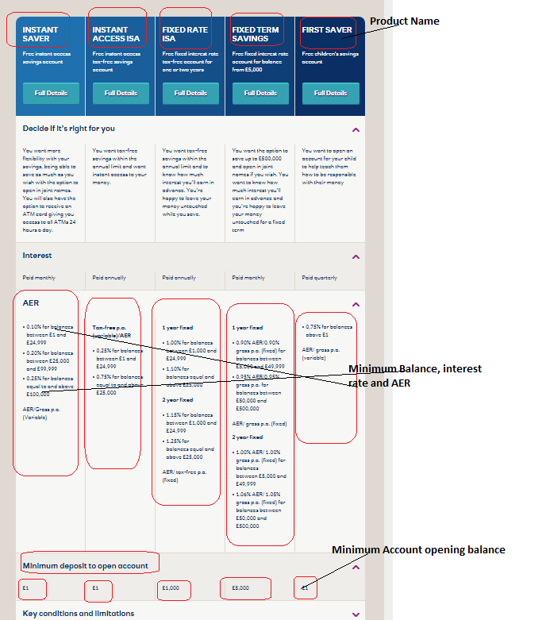

[**https://www.beta.rbs.co.uk/personal/current_accounts_in_england_wales.html**](https://www.beta.rbs.co.uk/personal/current_accounts_in_england_wales.html)

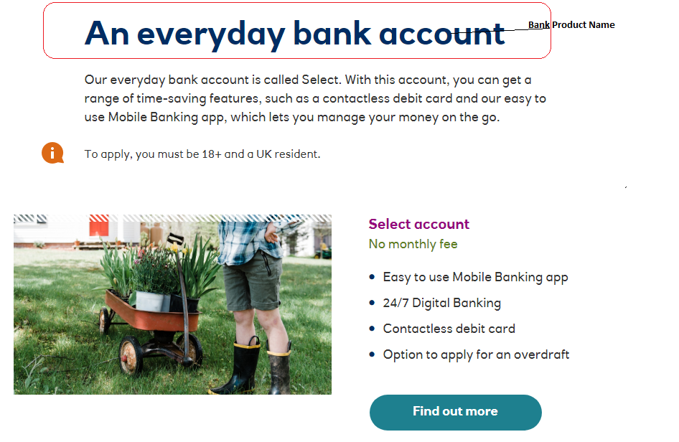

Work 2: Mortgage Rates

|  |  |
| --- | --- |
| **Mortgages Columns** | **Default Values** |
| Date | Date(YYYY-MM-DD) |
| Bank_Native_Country | UK |
| State | London |
| Bank_Name | Lloyds Bank |
| Bank_Local_Currency | GBP |
| Bank_Type | Bank |
| Bank_Product | Mortgages |
| Bank_Product_Type | Mortgages |
| Bank_Product_Name | SCRAPED DATA |
| Min_Loan_Amount | SCRAPED DATA |
| Bank_Offer_Feature | Offline |
| Term (Y) | SCRAPED DATA |
| Interest_Type | SCRAPED DATA (Variable, by default) |
| Interest | SCRAPED DATA |
| APRC | SCRAPED DATA |
| Mortgage_Loan_Amt | SCRAPED DATA |
| Mortgage_Down_Payment | 20% |
| Mortgage_Category | New Purchase |
| Mortgage_Reason | Primary Residence |
| Mortgage_Pymt_Mode | Principle + Interest |
| Fixed_Rate_Term | SCRAPED DATA <from title> |
| Bank_Product_Code | LEAVE THIS COLUMN BLANK |

<https://personal.rbs.co.uk/personal/mortgages/mortgage-calculators/mortgagefinder.html>

Case 1: Property Value: 90,000; Your deposit: 18,000

Case 2: Property Value: 270,000; Your deposit: 54,000

Case 2: Property Value: 450,000; Your deposit: 90,000

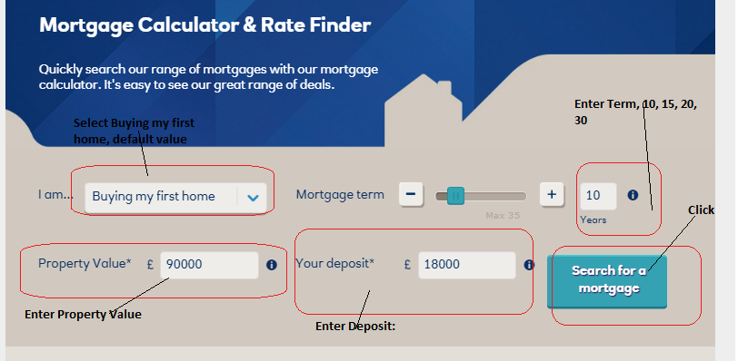

Click on Search for a mortgage

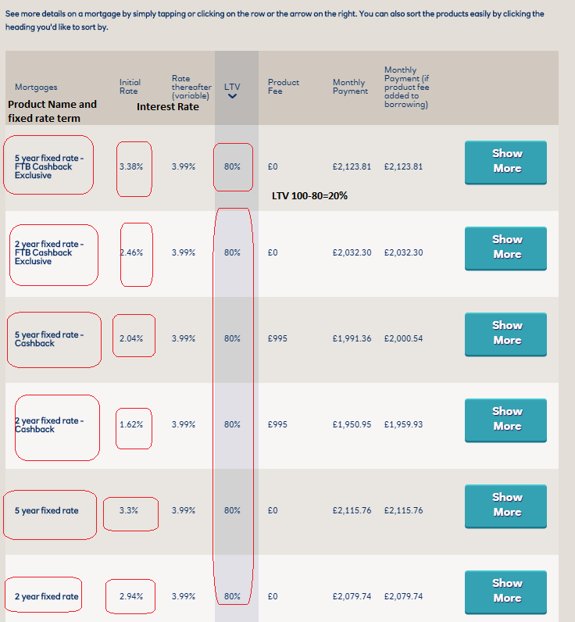

Click on show more

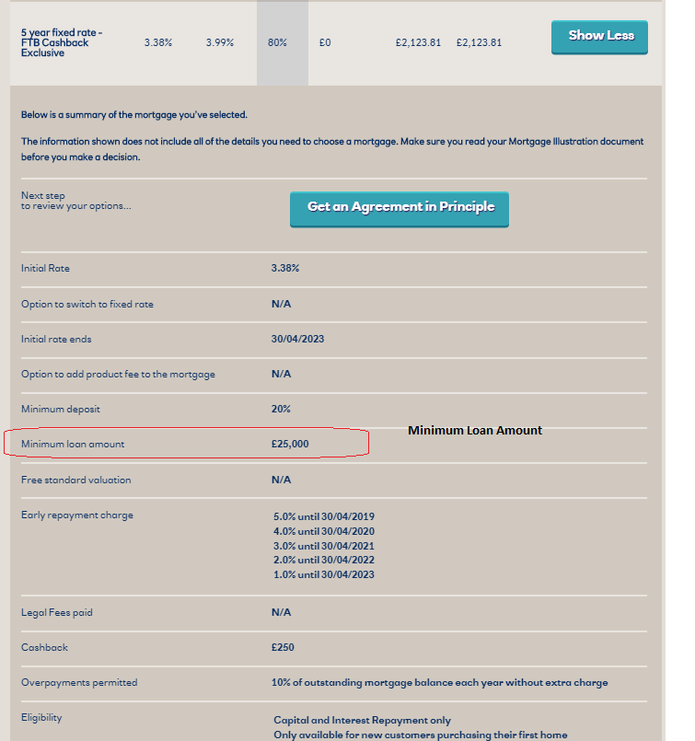

Repeat for 10, 15, 25, 30 year loan term

**Example for 1st Product:**

Product Name: 2 Year Fixed LTV 80%

Term: 10

Fixed_Rate_Term: 5

Mortgage_Down_Pymt: 20%

Interest: 3.38%

Min_Loan_Amt: 25000